Manager User Guide
Futures Timesheet Portal Overview
––––––––––––––––––––––––––––––––––––––––––––––––––––––––––––––––
- Instant and secure access to your account.
- Ability to instantly approve timesheets and expense claims.
- Automatic email reminders to approve timesheets and expense claims.
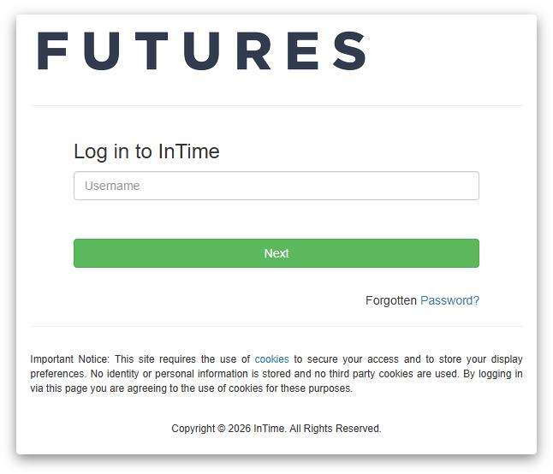
Accessing the Futures Timesheet Portal
––––––––––––––––––––––––––––––––––––––––––––––––––––––––––––––––
Once the contractor has passed compliance
checks, you will receive login details for the Futures Online Timesheet Portal. A link to the portal will be sent alongside your username and password. Please note that your password will be sent in a separate email for security reasons – the email subjects for these emails will be “Welcome to Futures Timesheet Portal” and “Futures Timesheet Portal Password”.
If you haven’t received either of these emails on
the day that the contractor is due to begin working, please contact: accounts@futures.co.uk or 0113 4574929.
Navigating the Homepage
––––––––––––––––––––––––––––––––––––––––––––––––––––––––––––––––
Once you have logged in to the Futures Portal, you will be presented with the homepage below.
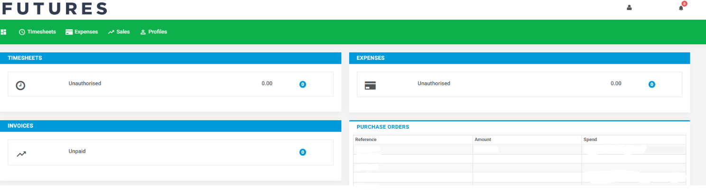

Navigation Menu Explained
Multi Square Icon – This will take you back to the homepage and can be accessed at all times.
Timesheets – This allows you to approve submitted and previously approved timesheets.
Expenses – This allows you to approve new and access historical expense claims.
Sales – This allows access to invoices and credit notes.
Compliance – To facilitate information requests and submit documentation.
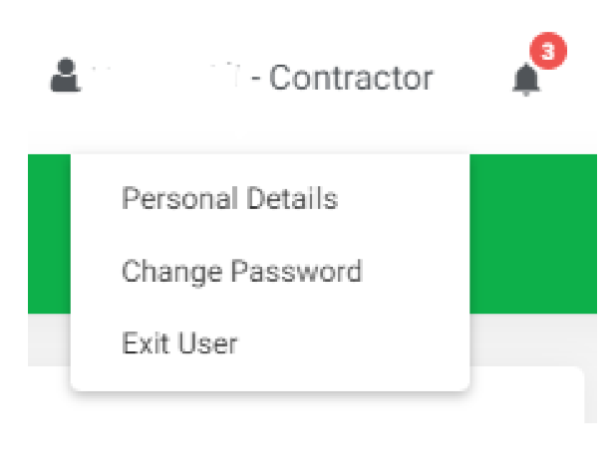
Profiles – This gives details of your placements and associated clients.
In the top right-hand corner of your screen:
- If you click on your name, options appear for you to:
- Update your personal details.
- Change password.
- Exit InTime.
- Bell Symbol – This advises you of any notifications.
- Help – Takes you to our online documentation help bank.
Your Dashboard
––––––––––––––––––––––––––––––––––––––––––––––––––––––––––––––––
As you scroll down your homepage, your personal dashboard will provide you with a real-time status of your current unauthorised timesheets, expenses and unpaid invoices.
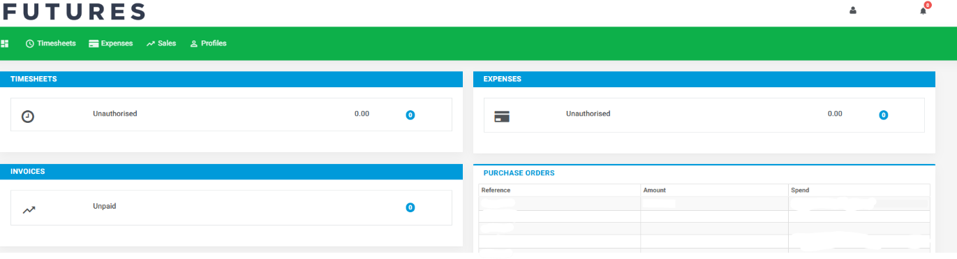
Timesheets and Expenses Status Explained
Authorise: Timesheets and expenses displayed are awaiting approval.
Unauthorised: Timesheets and expenses displayed are awaiting approval, but are viewable only on the dashboard.
Approved: An approved timesheet or expense is one that you have approved for payment.
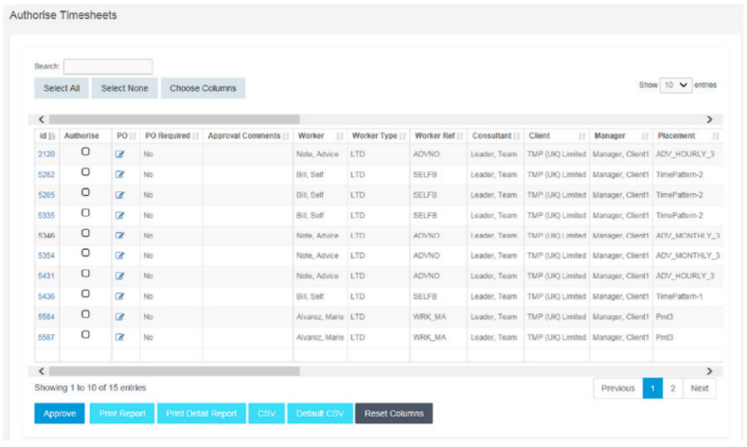
Rejected: A rejected timesheet or expense that has been rejected by you. You can provide a comment as to why the timesheet or expense was rejected. Once rejected, the timesheet becomes a draft for editing and resubmission by the contractor.
How to Approve Timesheets or Expenses
Go to Timesheet or Expenses on the menu bar and click “Authorise”.
You will then be presented with a list of all timesheets or expenses submitted by contractors that require your approval. Alternatively, you can use the dashboard on your homepage and select the appropriate item.
You can approve in one of two ways:
- Bulk approve: Tick each item listed in the Authorise column that you want to approve, enter your password and then click Approve.
- Approve each timesheet individually by clicking on the timesheet ID. You will see a summary of the placement and the timesheet details.
You must enter your password at the bottom of the screen and click either “Approve” or “Reject”.
If you select Reject, you will be presented with a new page asking for a reason for the rejection. This reason will be sent back to the contractor so they can act accordingly.
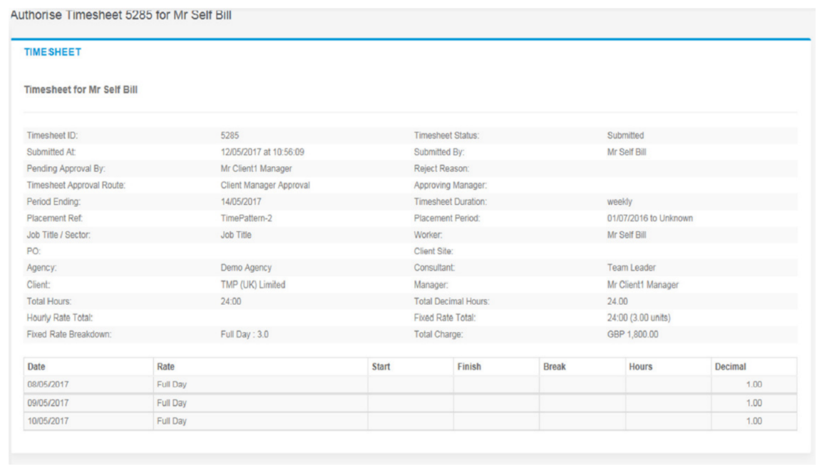

How to Approve Timesheets or Expenses (Email Approval)
Once a contractor has submitted their timesheet or expense claim, an email will be sent to their manager for approval. This email will contain the contractor name, timesheet ID, period ending date and total units worked.

If you would like to approve the timesheet, please click “Approve”. This will open an
email with prepopulated information necessary to submit your approval to the portal.
Please make sure you click “Send” without altering the subject line or any of the information.
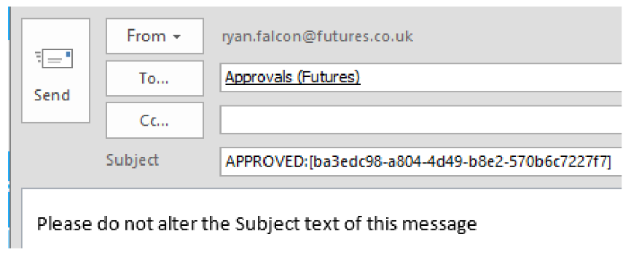
Our portal will automatically read the email that you send and update the timesheet status from submitted to approved.

