Contractor User Guide
Futures Timesheet Portal Overview
––––––––––––––––––––––––––––––––––––––––––––––––––––––––––––––––
- Instant and secure access to your account.
- Quick and simple creation of your timesheets and expense claims.
- Instant submission of timesheets or expense claims for approval.
- Notification of payments being made to you or to your umbrella company.
- The ability to simplify your administration processes by authorising Futures to self-bill.
- Automatic email reminders to submit timesheets and alerts so you are always kept up to date.
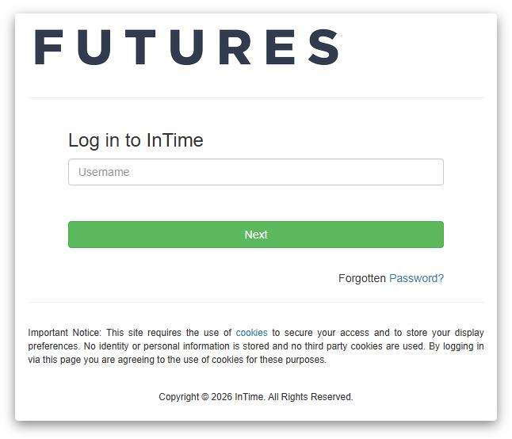
Accessing the Futures Timesheet Portal
––––––––––––––––––––––––––––––––––––––––––––––––––––––––––––––––
Once compliance checks have been completed, you will receive login details for the Futures Online Timesheet Portal. A link to the portal will be sent alongside your username and password. Please note that your password will be sent in a separate email for security reasons – the email subjects for these emails will be “Welcome to Futures Timesheet Portal” and “Futures Timesheet Portal Password”.
If you haven’t received either of these emails on the day that you’re due to begin working, please contact: accounts@futures.co.uk or 0113 4574929.
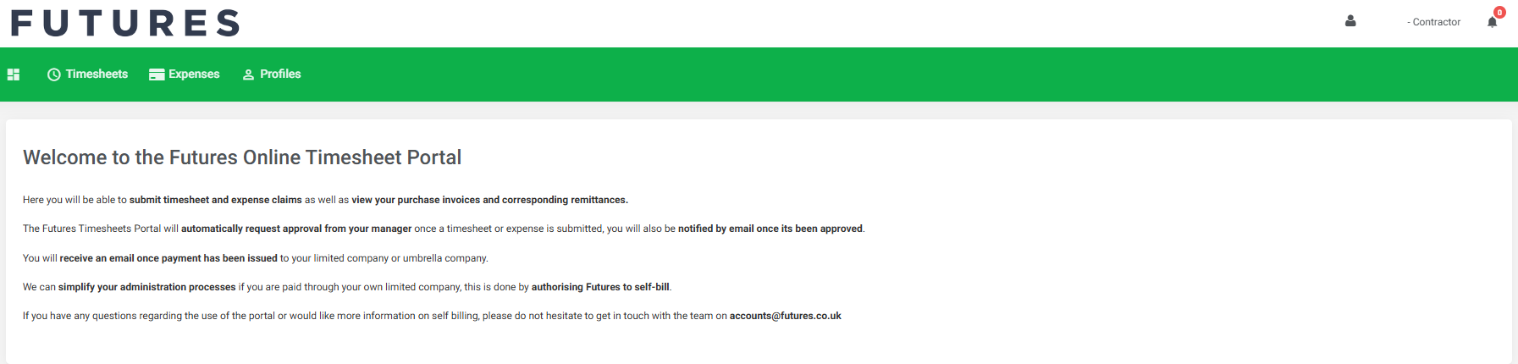
Navigating the Homepage
––––––––––––––––––––––––––––––––––––––––––––––––––––––––––––––––
Once you have logged in to the Futures Portal, you will be presented with the homepage below.

Navigation Menu Explained
Multi Square Icon – This will take you back to the homepage and can be accessed at all times.
Timesheets – This allows you to approve submitted and previously approved timesheets.
Expenses – This allows you to approve new and access historical expense claims.
Pay – This allows access to invoices and credit notes.
Compliance – To facilitate information requests and submit documentation.
Profiles – This gives details of your placements and associated clients.
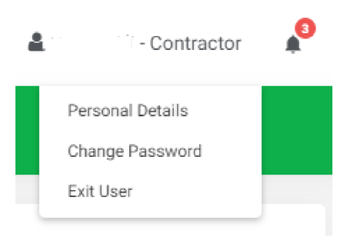
In the top right-hand corner of your screen:
- If you click on your name, options appear for you to:
- Update your personal details.
- Change password.
- Exit InTime.
- Bell Symbol – This advises you of any notifications.
- Help – Takes you to our online documentation help bank.
Your Dashboard
––––––––––––––––––––––––––––––––––––––––––––––––––––––––––––––––
As you scroll down your homepage, your personal dashboard will provide you with a real-time status of your current placement information, timesheets, expenses, and contract documentation that you can easily access directly from the dashboard.
Timesheets and Expenses Status Explained
Missing: Timesheets that should be received during a specified date range but have not yet been created.
Draft: Timesheets that have been saved but not yet submitted. There are no draft expenses.
Submitted: Created and submitted for approval. Once submitted, these cannot be modified.
Approved: Approved by your manager for payment.
Rejected: Rejected by your manager. This is usually because of incorrect hours or expense lines. The manager may have provided a comment as to why the timesheet or expenses were rejected. Once rejected, the timesheet becomes a draft for editing and resubmitting.

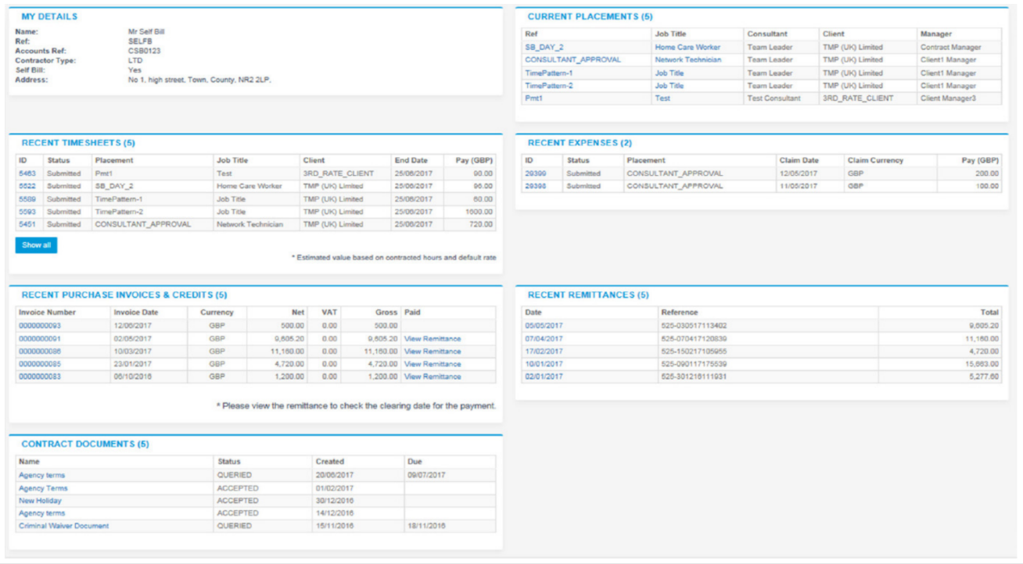

Entering Your Timesheets
––––––––––––––––––––––––––––––––––––––––––––––––––––––––––––––––
To begin, hover over Timesheets from the main menu bar at the top of the screen and then select Create. You will then be prompted to select the placement from the drop-down box to enter the time against, as well as the week ending date. You can use the provided calendar popup to help you select the correct date.
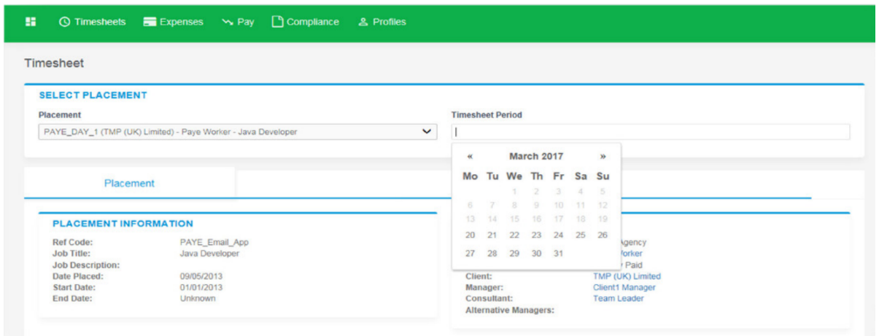

After selecting the period, you will be presented with a blank timesheet similar to the screenshot shown below:
If you’re paid a daily rate, please submit your timesheet so 1 unit = full day worked or 0.5 unit = half day worked.
Your placement will automatically calculate your total pay; this is viewable just below the timesheet.

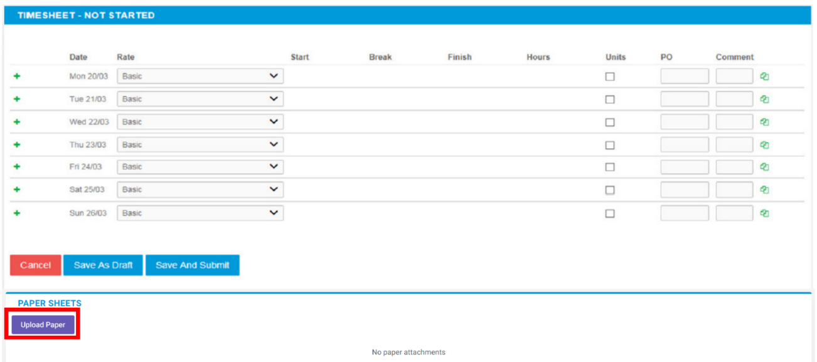

Please note: You must upload your Highlight Report before submitting your timesheet; failure to do so may result in your timesheet being rejected, which will subsequently delay payment.
You can click on “Save as Draft” to store the timesheet, which will allow you to return to this information to edit.
Once you have completed your timesheet, click on the “Save and Submit” button, and your timesheet will then be sent to your Manager for approval.
Draft Timesheets
If you have created timesheets and saved them previously without submitting, you can still access them by selecting Drafts from the Timesheet menu. You will then be taken to the timesheet form described in the Entering Your Timesheets section. Please refer to these instructions to edit and submit your draft timesheet.
If you have multiple draft timesheets you wish to submit for approval, tick the box in the Submit column against the applicable timesheet and click on Submit. If you need to access a specific timesheet, click on the number in the ID column to view, edit, or submit.
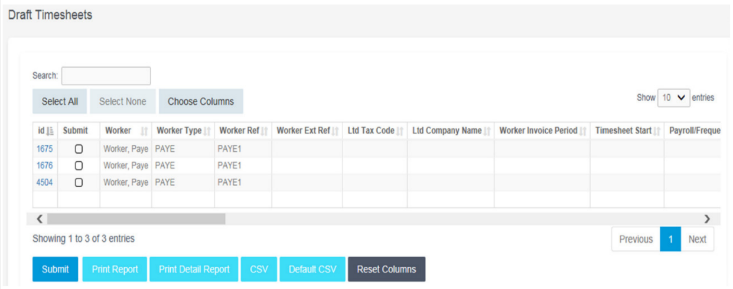

Submitted Timesheets
If you need to check the status of your submitted timesheets, you can use your dashboard and see the status, or use the Unauthorised, Approved or Rejected options from the Timesheets menu. By clicking the timesheet ID you can also see a detailed view of that timesheet.
Please note: You can only modify timesheets that have been rejected.
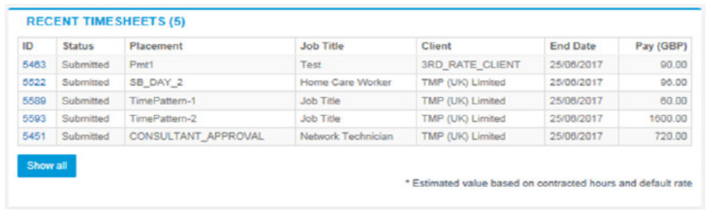

Entering Your Expenses
––––––––––––––––––––––––––––––––––––––––––––––––––––––––––––––––
Please note: By default, you will be unable to submit expenses. If you believe you are entitled to expense claims, please contact your consultant, and this option can be enabled.
Once enabled, hover over Expenses from the main menu bar at the top of the screen and then select Create. You will then be prompted to select the client and placement you wish to claim expenses against. After selecting this, you will be presented with a blank expenses claim form as shown below:
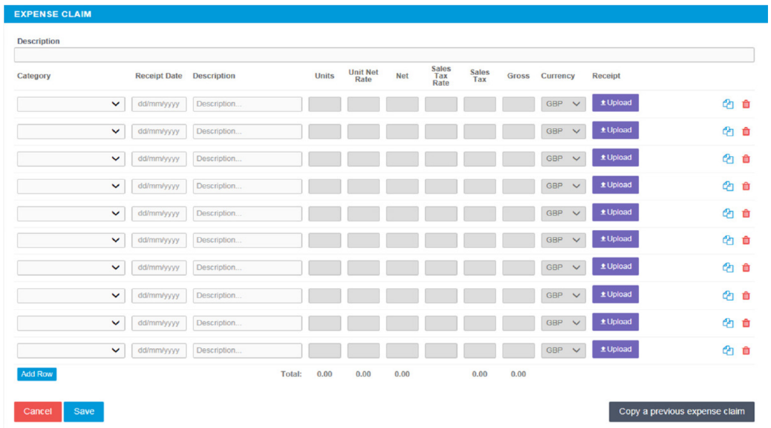

Select the correct category of expense and description from the provided dropdowns. Please upload any receipts or supporting documents, as these will be sent to your manager for approval.
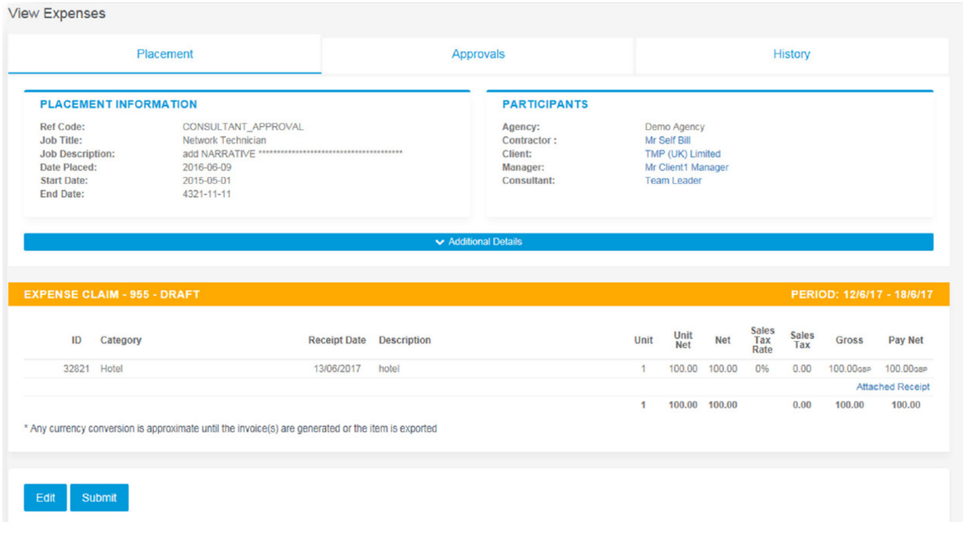
Once you have filled in all the required fields, hit save. You will then get a summary of your expenses. If you need to edit your claim, please click the Edit button. Once you have finished your expense claim, click Submit.

Submitted Expenses
If you need to check details of your submitted expense claim, or to see if your manager has approved them, click Unauthorised, Approved or Rejected on the Expenses menu.
You can now view the status and summary of your submitted expense claim. By clicking the relevant expense item, you will be able to see a detailed view of the expense.
Please note: You can only modify expense claims that have been rejected.
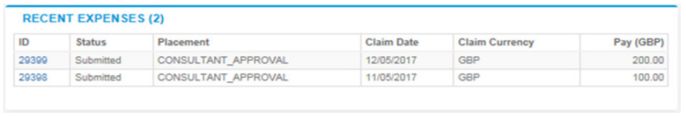

Invoice and Billing
––––––––––––––––––––––––––––––––––––––––––––––––––––––––––––––––
If you are a Limited Company contractor and don’t have a self-bill agreement in place, you will receive an advice note via email. An advice note doesn’t confirm payment and is not a sales tax invoice, and as such doesn’t include VAT. It’s raised once we receive an approved timesheet and helps contractors in raising their invoices as the information, such as w/e date, days worked and pay rate are all included.
Please contact accounts@futures.co.uk if you would like to start self-billing, and we will send over the necessary documentation.
Remittances and Payments
––––––––––––––––––––––––––––––––––––––––––––––––––––––––––––––––
Once payment has been processed on the Futures portal, you will be able to view your remittance.
The table below is accessible from your personal dashboard. The date shown is when funds have been credited to your account (this is usually Friday each week). If you click on the date, it will open your remittance, which outlines each invoice which has been paid to you. You’ll also be able to download your invoice directly from this remittance.
